Evangelist-Daniel Ruegg Email-epaphras11@earthlink.net Web site-mariettarenochurchofchrist.org

Meeting Times
Sunday Bible Study-9:30 am Sunday Morning Worship-10:30 am Sunday Evening Worship-6:30 pm Wednesday Bible Study-7:00 pm

Weekend VBS is August 3rd and 4th

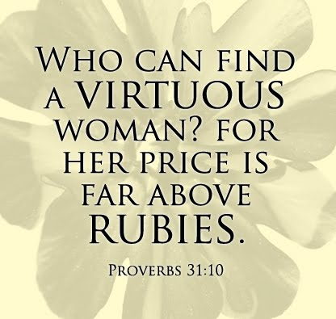

The Virtuous Woman

Today is Mother’s Day. Just in case some of you forgot. The origin of a day to honor mothers in the United States is credited to Anna Davis from Grafton West Virginia. The notion that a good and virtuous woman should be praised and honored was not an original thought. King Lemuel’s Mother had some very good advise for him and us in reference to finding and honoring a virtuous woman.

Proverbs 31:10-31

10 Who can find a virtuous wife? For her worth is far above rubies.11 The heart of her husband safely trusts her; So he will have no lack of gain.12 She does him good and not evil All the days of her life.13 She seeks wool and flax, And willingly works with her hands.14 She is like the merchant ships, She brings her food from afar.15 She also rises while it is yet night, And provides food for her household, And a portion for her maidservants.16 She considers a field and buys it; From her profits she plants a vineyard.17 She girds herself with strength, And strengthens her arms.18 She perceives that her merchandise is good, And her lamp does not go out by night.19 She stretches out her hands to the distaff, And her hand holds the spindle.20 She extends her hand to the poor, Yes, she reaches out her hands to the needy.21 She is not afraid of snow for her household, For all her household is clothed with scarlet.22 She makes tapestry for herself; Her clothing is fine linen and purple.23 Her husband is known in the gates, When he sits among the elders of the land.24 She makes linen garments and sells them, And supplies sashes for the merchants.25 Strength and honor are her clothing; She shall rejoice in time to come.26 She opens her mouth with wisdom, And on her tongue is the law of kindness.27 She watches over the ways of her household, And does not eat the bread of idleness.28 Her children rise up and call her blessed; Her husband also, and he praises her:29 Many daughters have done well, But you excel them all.30 Charm is deceitful and beauty is passing, But a woman who fears the Lord, she shall be praised.31 Give her of the fruit of her hands, And let her own works praise her in the gates.
Lemuel’s mother starts off explaining the rarity of finding this type of woman. She is a precious treasure that is not easily found. She is more valuable than the finest gemstones. She then explains her attributes.

Her husband doesn’t have to worry about where she is and what she’s doing. He fully trusts her and he knows what needs to be done will get done. She strives to do good for her husband. She is hard working and tireless. She looks out for the best interest of her family and makes sure they are taken care of. She is not a procrastinator and works hard to make sure the family has what they need when they need it if not before. She full of good works giving to the poor and needy. Her family has a good name because of her. She provides for the family selling some to the goods she makes. She is far too busy taking care of her family and her business to meddle in other people’s lives.

Her children, her husband, and others praise her. The fruit of her labors praise her too.

On Mother’s Day as we honor the virtuous woman or women who have touched our lives remember the words of King Lemuel’s Mother. Whether you call her Wife, Mother, or Sister please realize what a rare and precious gift she is. Praise and honor her not just on this special day but everyday.

Happy Mother’s Day

Aaron Fleenor

