Evangelist-Daniel Ruegg Email-epaphras11@earthlink.net Web site-mariettarenochurchofchrist.org

Meeting Times
Sunday Bible Study-9:30 am Sunday Morning Worship-10:30 am Sunday Evening Worship-6:30 pm Wednesday Bible Study-7:00 pm

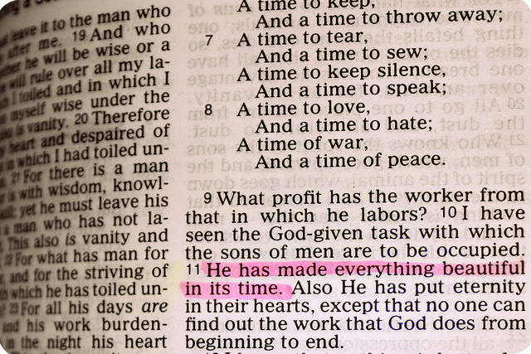

An Article About Nothing

There are times in everyone’s life when we feel compelled to do or say something.
Perhaps it’s when we are provoked to anger or when we experience some joyful event or even still when we feel deep remorse or sadness. The Bible is very clear in the fact that many times the very best course of action is to say and or do….nothing!

The wise man Solomon said there is, a time to rend, and a time to sew; a time to keep silence, and a time to speak; Ecclesiastes 3:7. However, mankind tends to follow his own way and to allow his own wisdom to guide him along. After all, we’ve experienced things in our life, we’ve been “around the block” a time or two so why shouldn’t we express ourselves for the world to see and hear? If you are a Bible student at all, floods of scripture should be flowing from your mind right now as to why trusting our own wisdom is dangerous business. Here are a few….

Jeremiah 10:23 O LORD, I know that the way of man is not in himself: it is not in man that walketh to direct his steps.
1Corinthians 3:19 For the wisdom of this world is foolishness with God. For it is written, He taketh the wise in their own craftiness.
Proverbs 3:5 Trust in the LORD with all thine heart; and lean not unto thine own understanding.

The book of James (often called the Proverbs of the New Testament) speaks of the dangers of the tongue and how we must work diligently to try and control it. It will never be completely “tamed” but it can be controlled. James also speaks of self control and the patience it produces. (James 1:2-4 and 3:8)
James also gives some of the greatest advice man has ever received, when he said…. “Wherefore, my beloved brethren, let every man be swift to hear, slow to speak, slow to wrath:”..James 1:19
Before we speak or act, let’s take a moment to consider the situation at hand. What should we say or do? What tone should we use? How will our actions be received?
What will be the end result of what we say and do?
Many relationships have been damaged or completely destroyed by hurtful words and actions that really never needed to be expressed. How are we using the golden gift of silence? After all, sometimes nothing can really mean a lot.
Kent Parks

For everything there is a season, and a time for every matter under heaven:
a time to be born, and a time to die;
a time to plant, and a time to pluck up what is planted;
a time to kill, and a time to heal;
a time to break down, and a time to build up;
a time to weep, and a time to laugh;
a time to mourn, and a time to dance;
a time to cast away stones, and a time to gather stones together;
a time to embrace, and a time to refrain from embracing;
a time to seek, and a time to lose;
a time to keep, and a time to cast away;
a time to tear, and a time to sew;
a time to keep silence, and a time to speak;
a time to love, and a time to hate;
a time for war, and a time for peace.
(Ecclesiastes 3:1-8 ESV)

